A000-US-OH-Adams Co.-Bannerstone-Banded Slate-8000-1000 BCE

# 

# 

# 

US-OH-Adams Co.-Bannerstone-Banded Slate-8000-1000 BCE

Case no.: 11

Accession Number:

Formal Label:

**Display Description:** US-OH-Adams Co.-Bannerstone-Banded Slate-8000-1000 BCE

**LC Classification:**

Date or Time Horizon: 8000-1000 BCE

Geographical Area: OH-Adams C

**Map:**

**GPS coordinates:**

Cultural Affiliation:

Media:

Dimensions: 2-7/8"L by 2-1/8

Weight:

Condition:

Provenance: Ex Patterson Collection

**Discussion:**

**References:**

# Order details

## Sales order

Sold by [razorbacknation2...](http://myworld.ebay.com/razorbacknation2013) ( [938](http://feedback.ebay.com/ws/eBayISAPI.dll?ViewFeedback&userid=razorbacknation2013) )

### Delivery package 1 of 1

Estimated delivery Tuesday, Jan 12, 2016

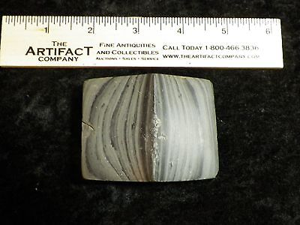

#### [Authentic Ohio Slate Bannerstone Indian Artifact](http://www.ebay.com/itm/191766409979)

|  |  |
| --- | --- |
| Item price | $200.00 |
| Quantity | 1 |
| Item number | 191766409979 |
| Shipping service | Economy Shipping |

## Shipping address

Ralph J Coffman Jr

149 Atlantic Ave

Swampscott MA 01907-2427

United States

## Order total

|  |  |
| --- | --- |
| Subtotal | $200.00 |
| Shipping | Free |

**Total** $200.00